**Design Document**

**Environment**

The environment will feature an enclosed pond area surrounded by trees, with the player standing in front of the pond. The main focus will be a large cherry blossom tree across the pond from the player. The tranquillity aspects will come from the natural environment, tranquil sound effects (such as water, bird song) and colour palette. Wonder will be created through subtle aspects such as having luminous flowers close to the pond which will spark the curiosity of the player and the beauty of nature. There will also be a sense that the player is the first person to visit this area in a long time, leading them to feel like they are making a discovery. This will be demonstrated through aspects such as the long unruly grass, the many wild flowers growing in the area and the lily pads and water lilies floating in the pond, making the area like it has been untouched for a long time.

**Audio**

* Bird song
* Gentle water sounds
* Breeze

**Assets**

* Trees
* Terrain
* Grass
* Cherry blossom tree
* Stones/rocks
* Long grass
* Luminous flowers
* Wild flowers

**Textures**

Atlases for:

* Flowers – colour, opacity, emissive
* Plants – colour, opacity
* Pond – colour, opacity, emissive
* Terrain – colour, opacity
* Trees – colour, opacity

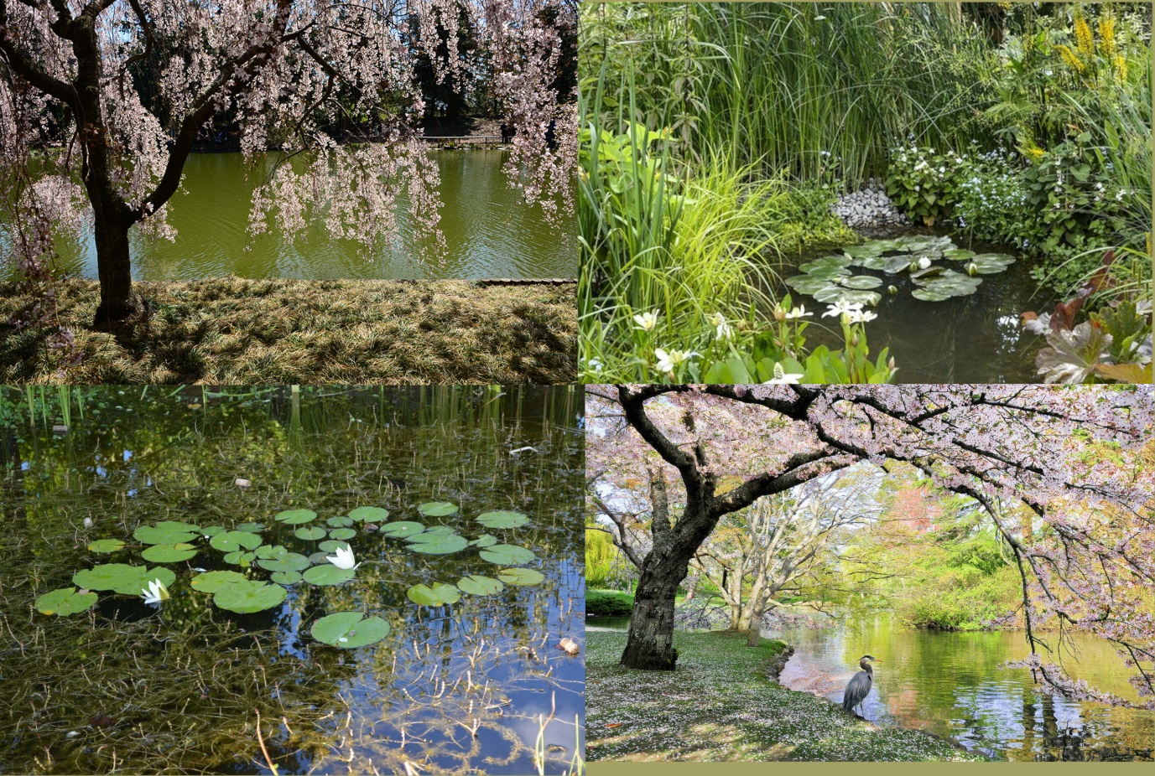**Moodboards**

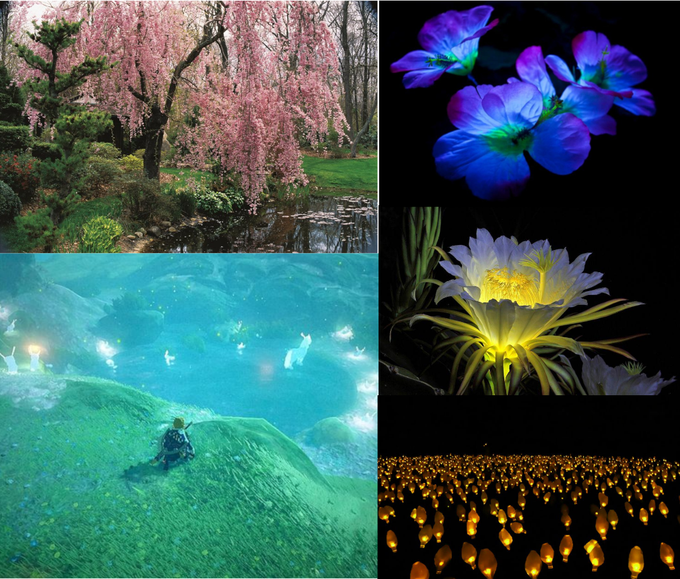

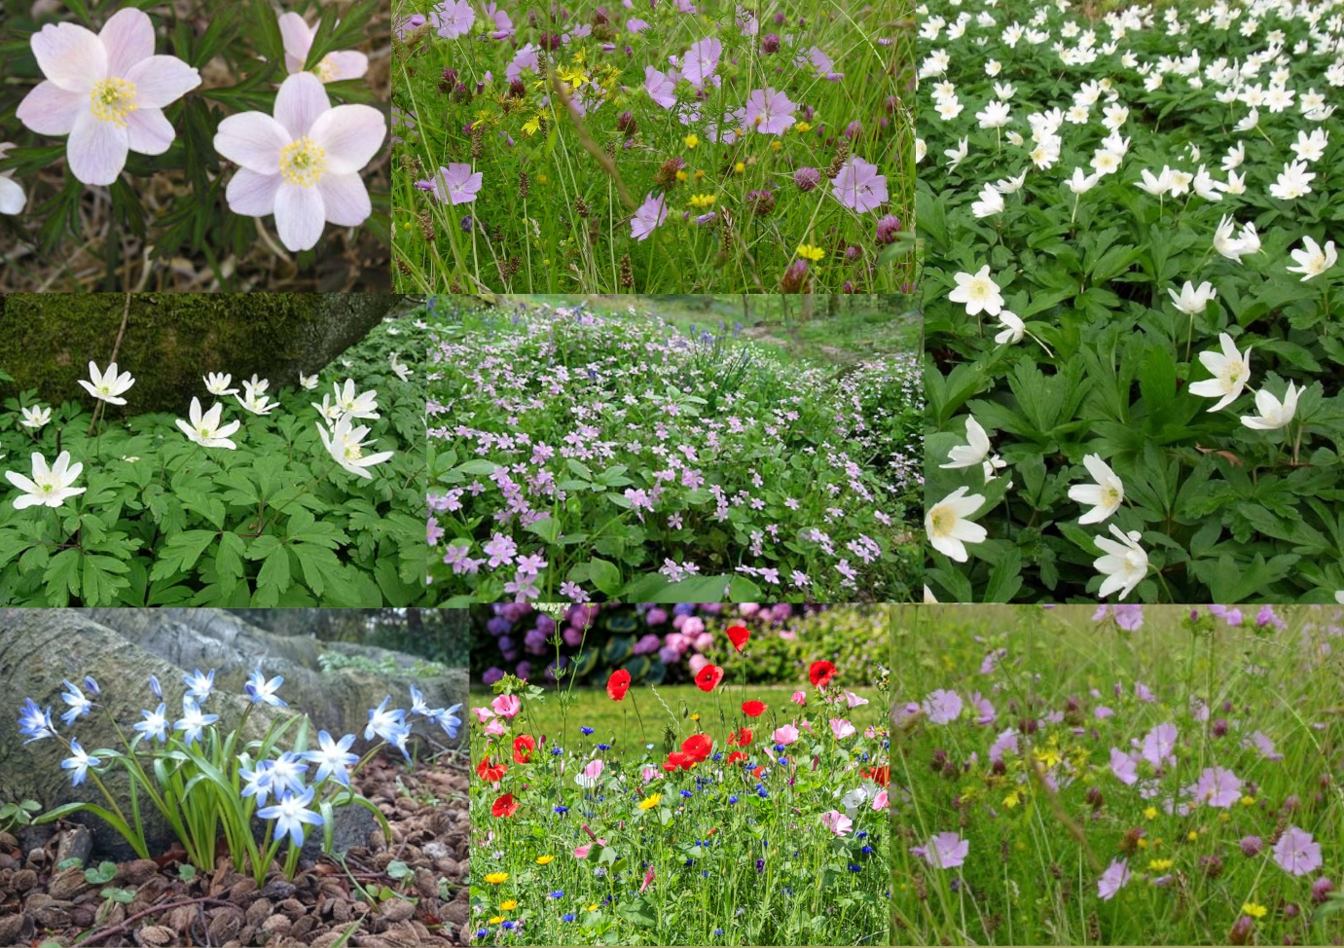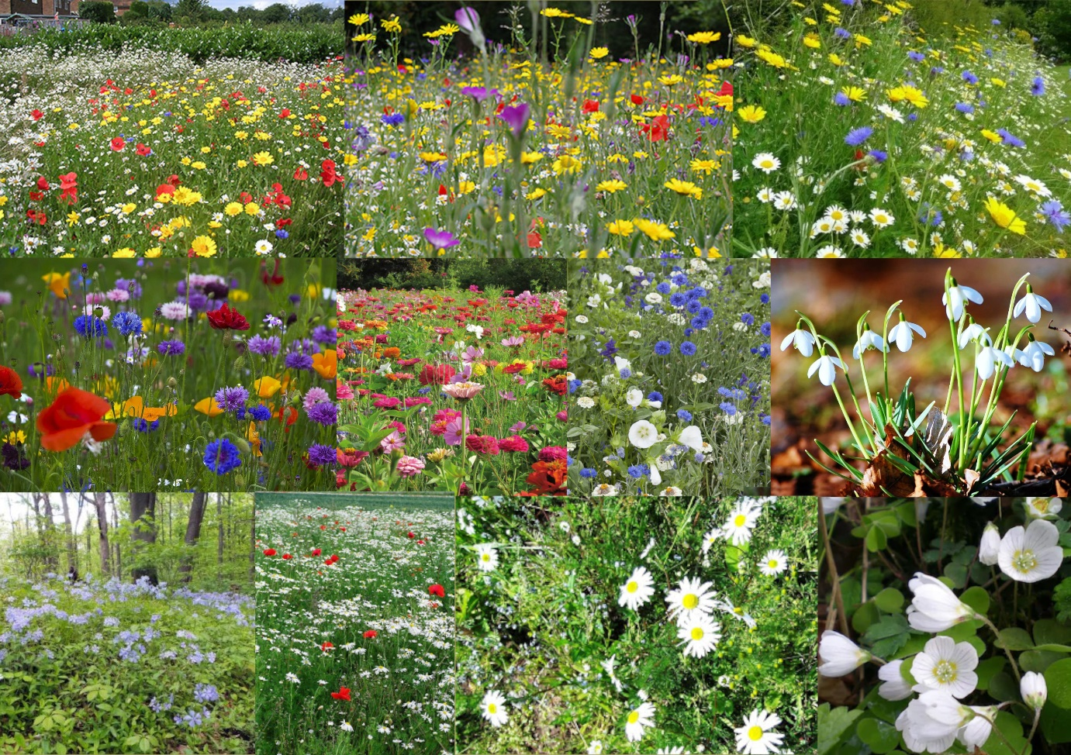

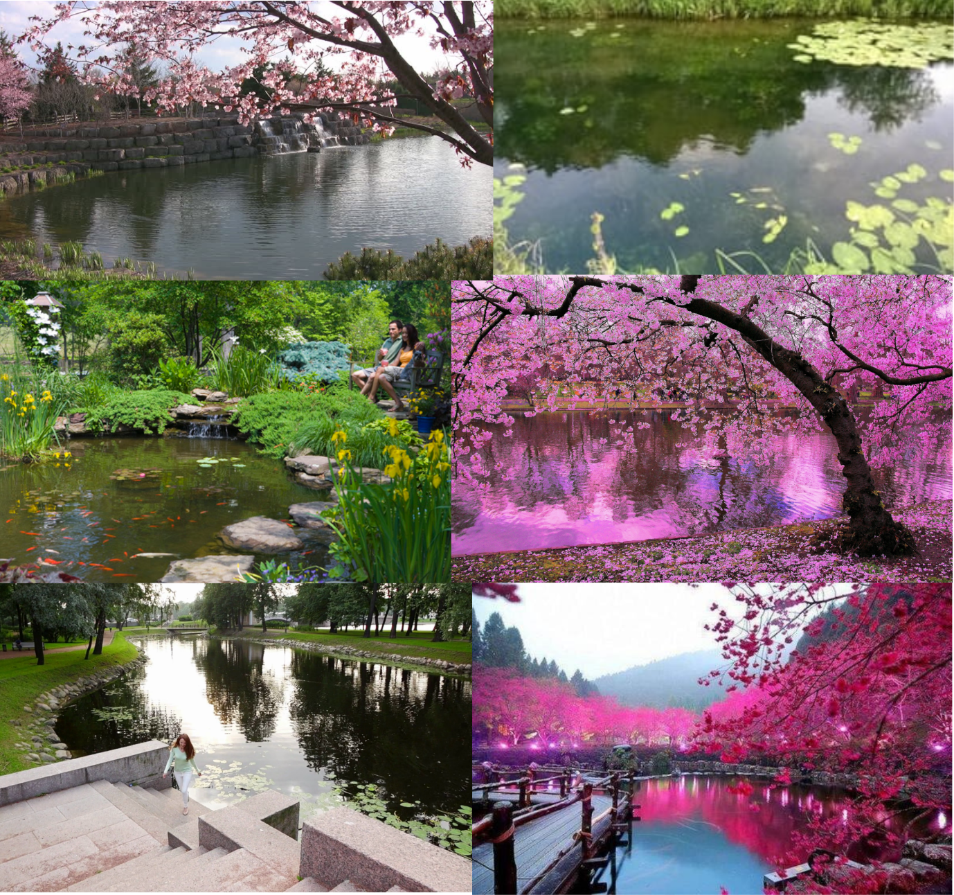

**Emotions**

Tranquillity, relaxation, peace

Created through:

* Natural environments
* Water
* Nature sound effects
* Greenery
* Colour palette – greens, blues, pink

Wonder, curiosity, joy

Created through:

* Subtle luminous aspects
* Engaging senses – audio and visual
* Beauty of nature